TRIGGERS AND PROCEDURES
2520030074
K. BHARGAVI
STEP-1: CREATE DATABASE
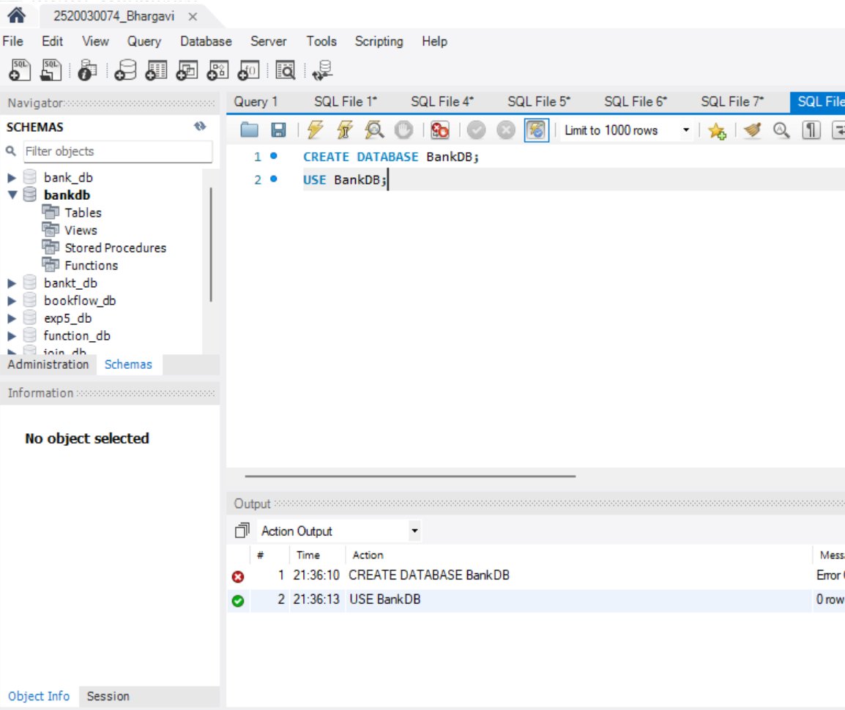
STEP-2: CREATE TABLES
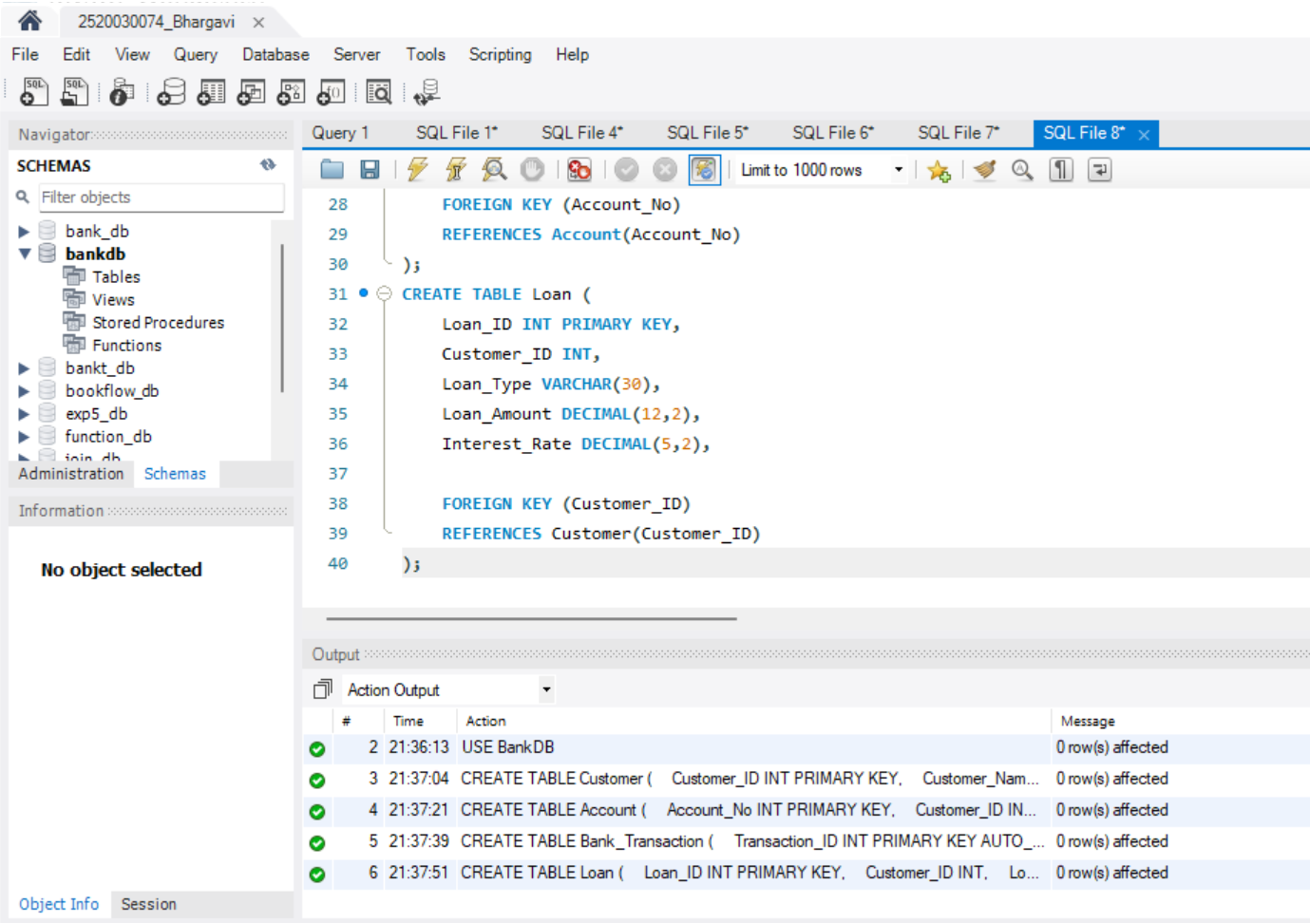
STEP-3: INSERT DATA INTO TABLES
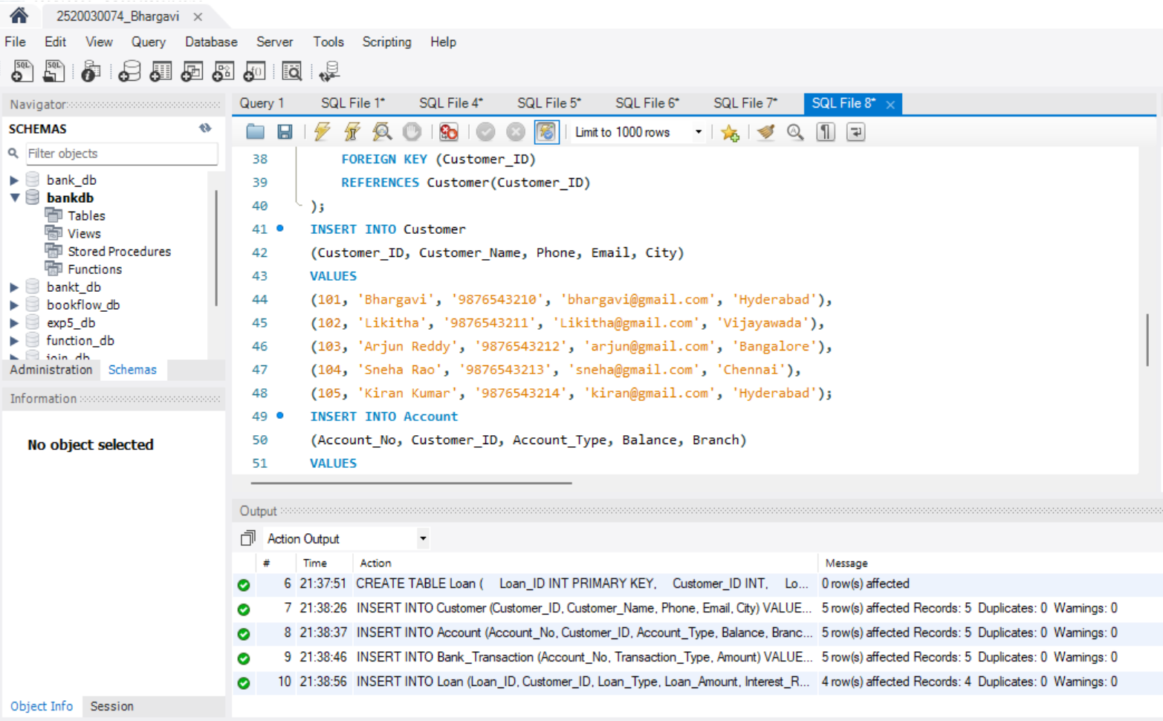
STEP-4: DISPLAY ALL TABLES DATA
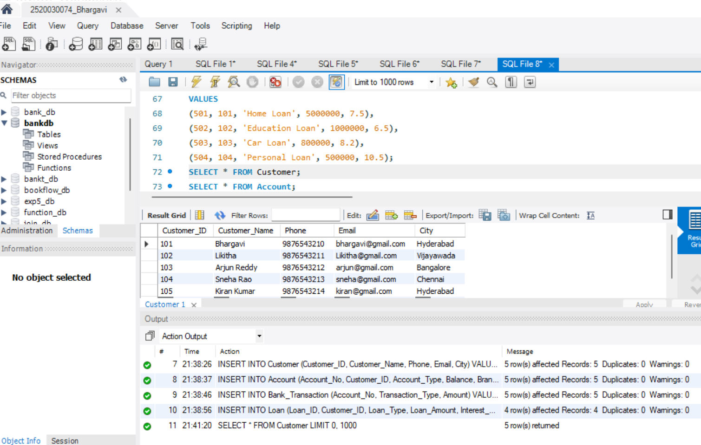
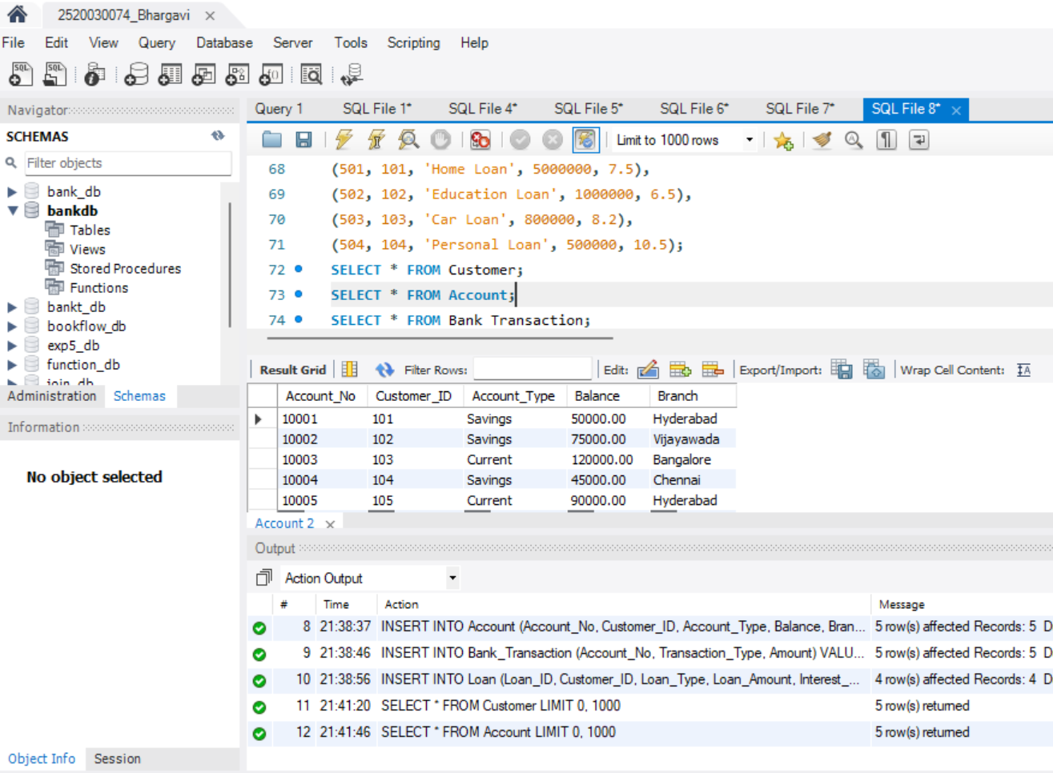
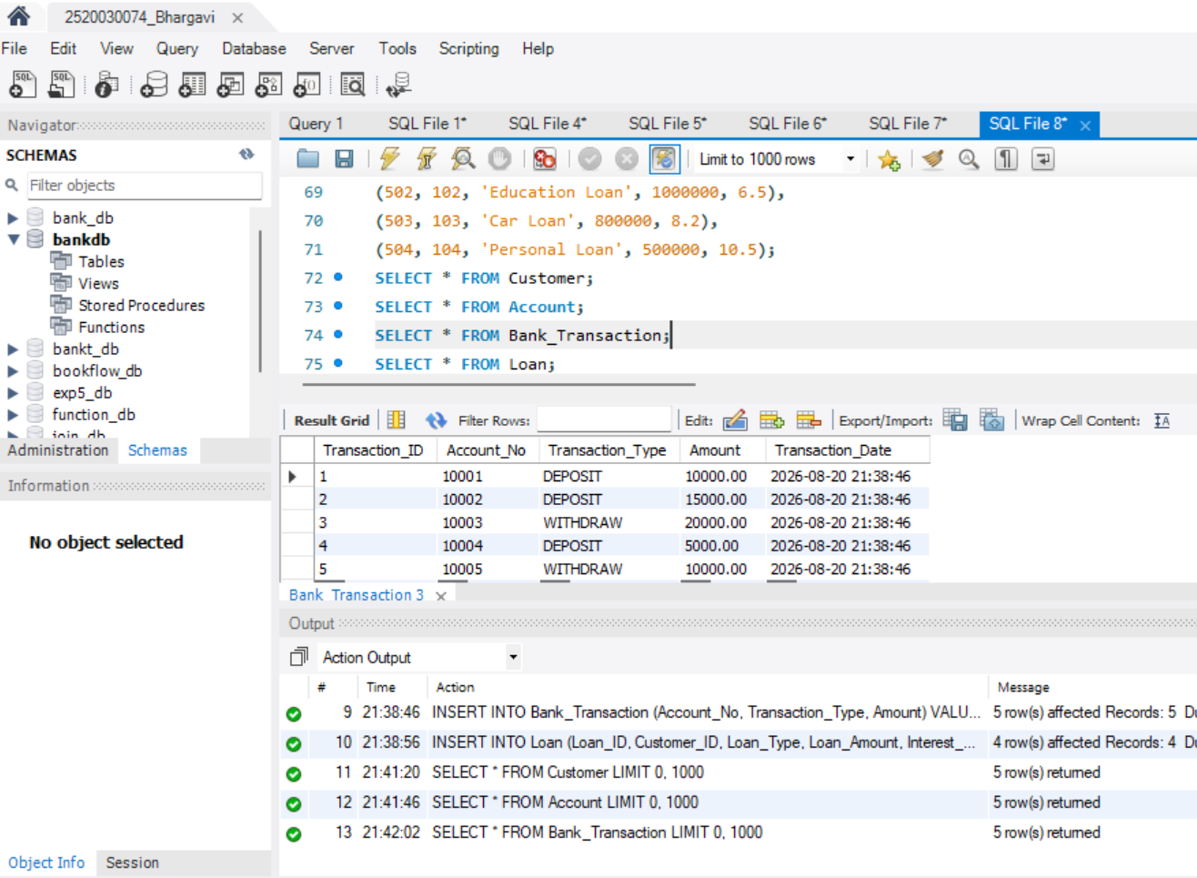
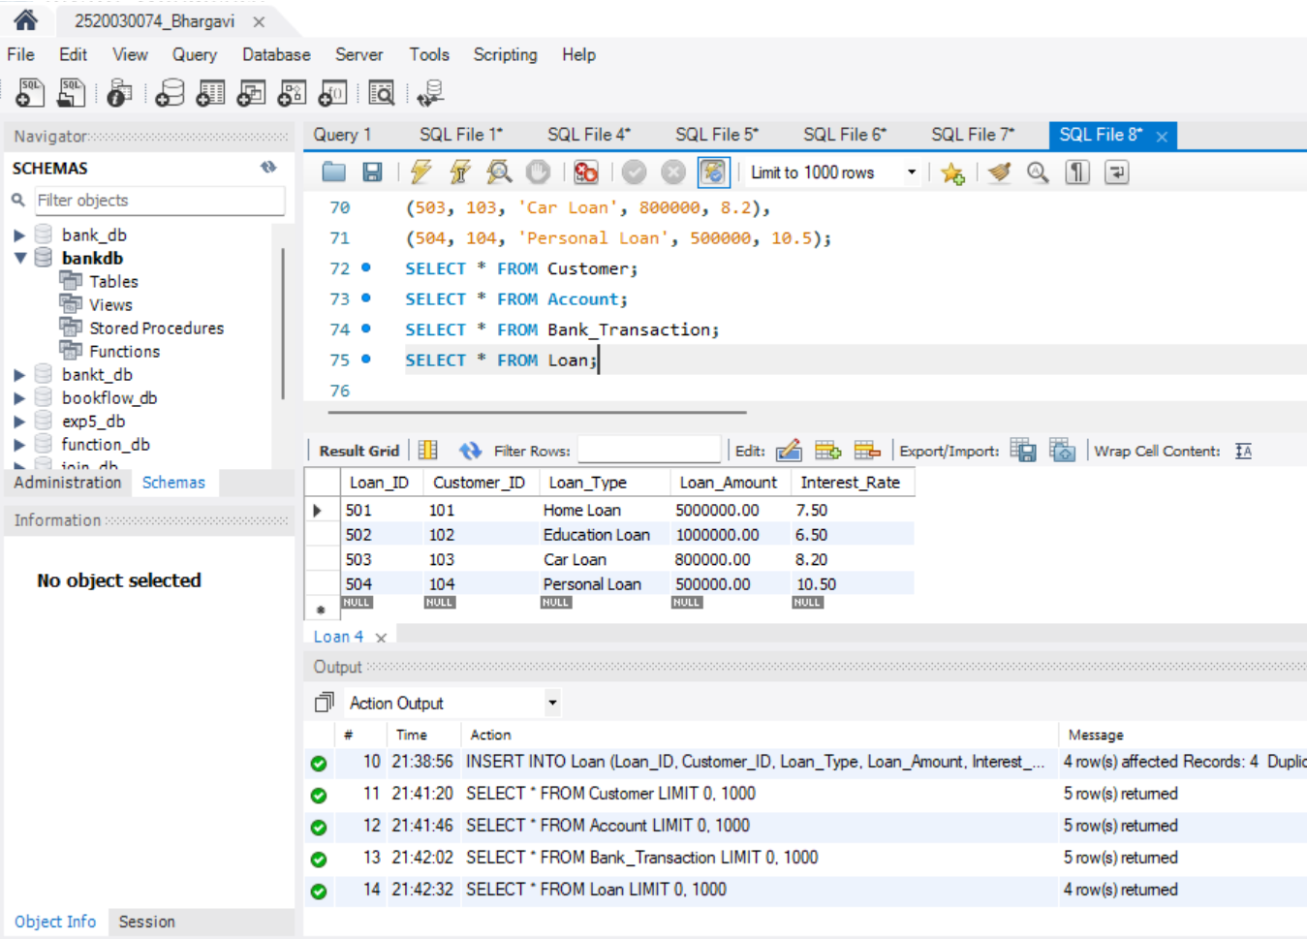
STEP-5: PROCEDURE TO DISPLAY ALL CUSTOMERS
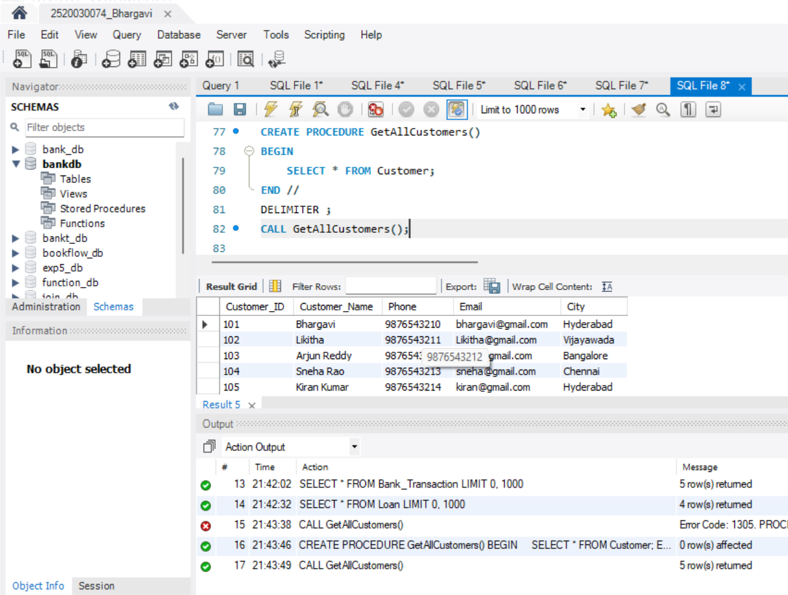
STEP-6: PROCEDURE TO DISPLAY ACCOUNT DETAILS
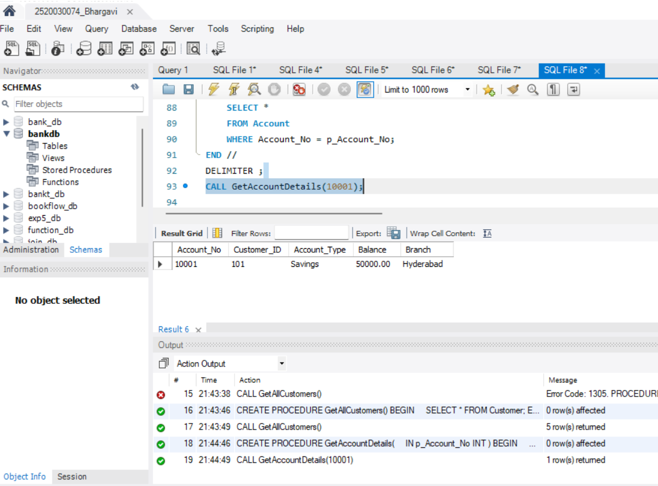
STEP-7: PROCEDURE TO FIND CUSTOMER ACCOUNTS
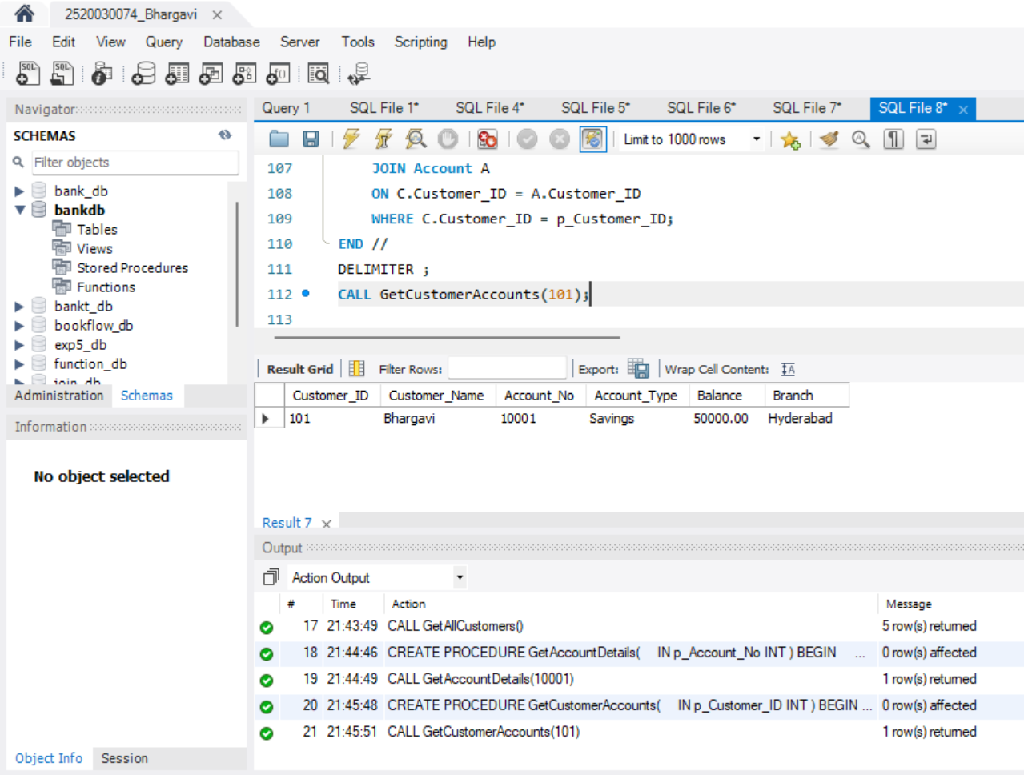
STEP-8: PROCEDURE TO DEPOSIT MONEY
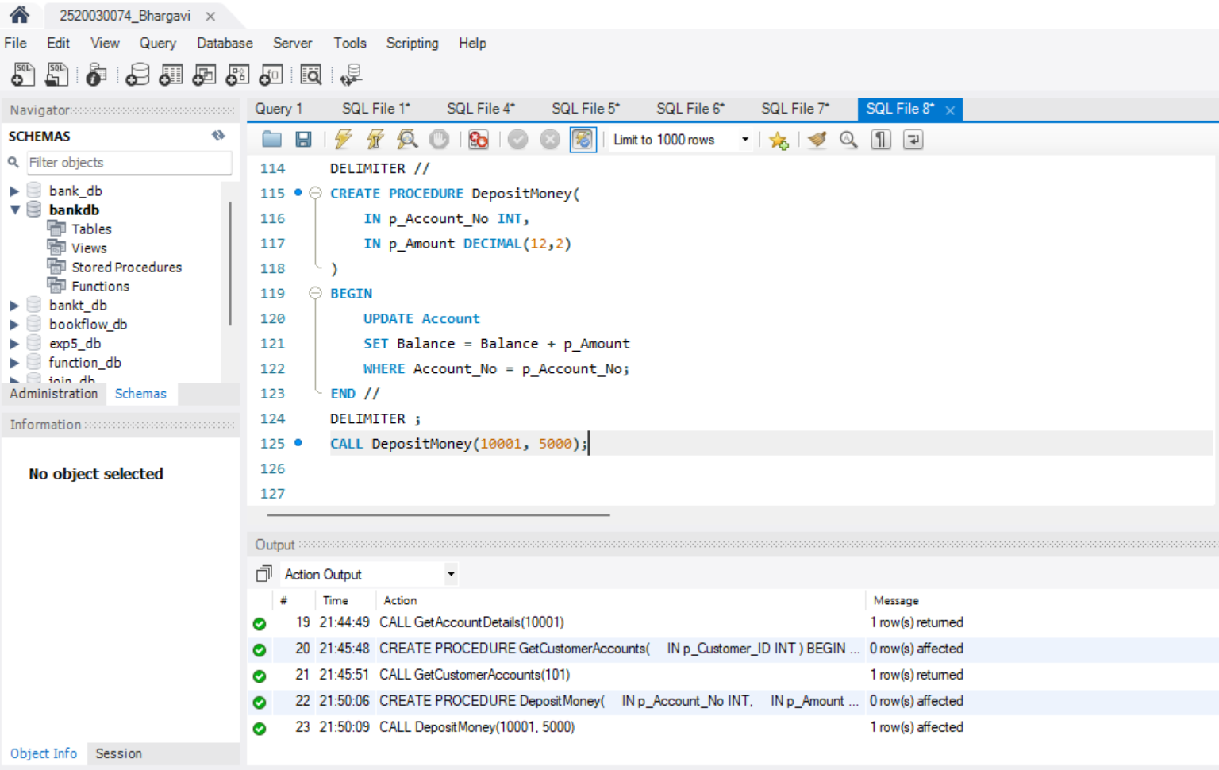
STEP-9: PROCEDURE TO WITHDRAW MONEY
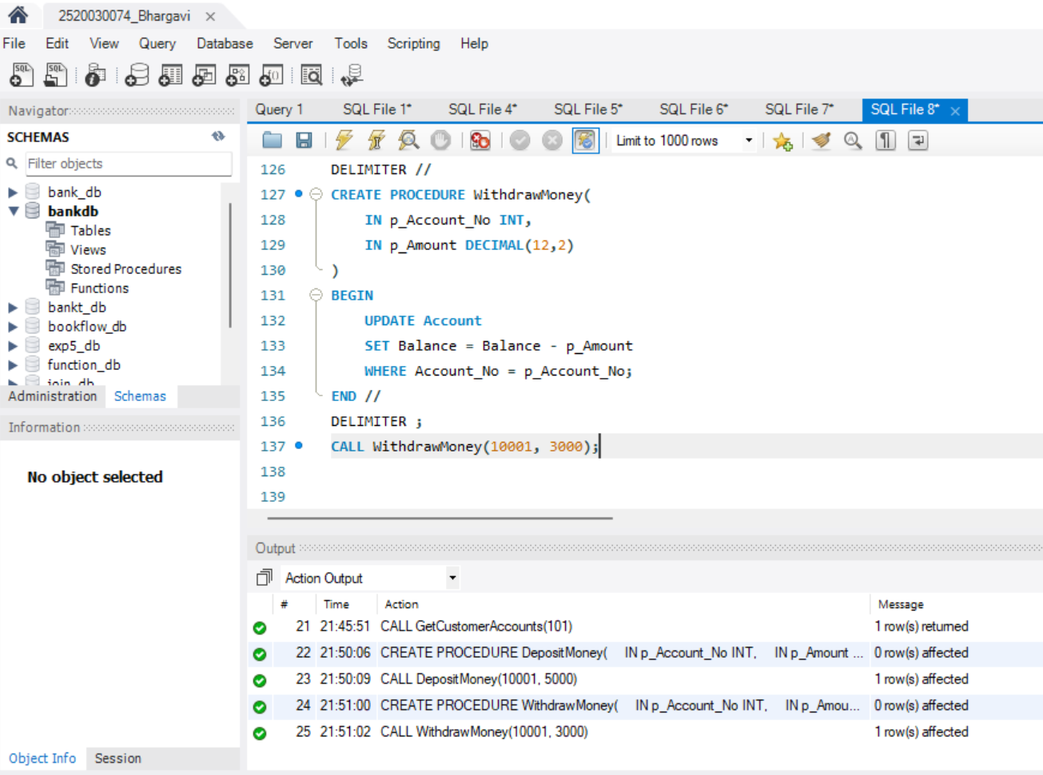
STEP-10: TRIGGER – PREVENT NEGATIVE BALANCE
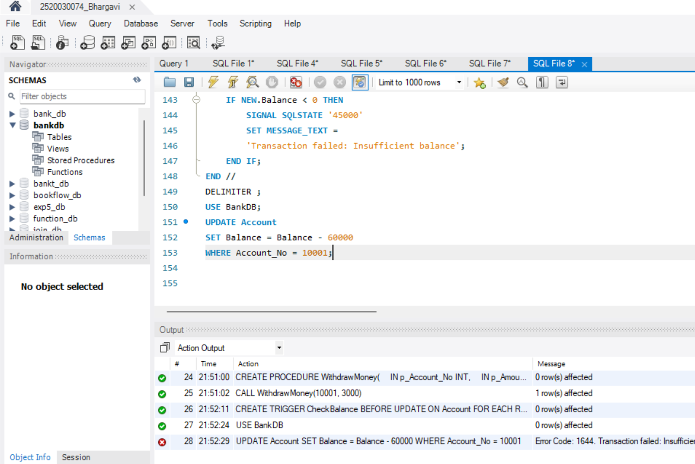
STEP-11: TRIGGER – PREVENT NEGATIVE TRANSACTION
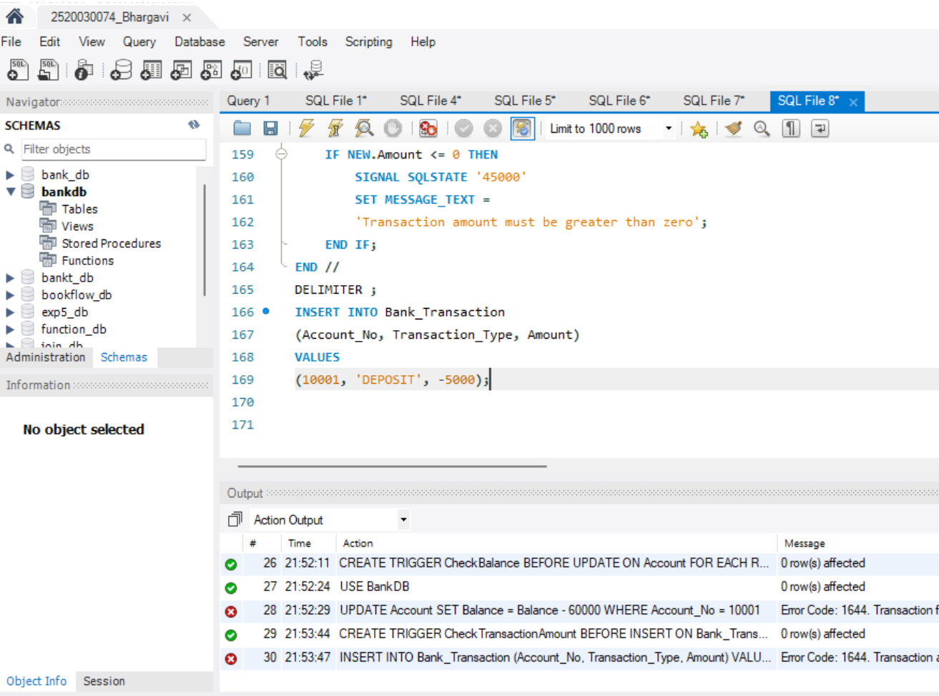
STEP-12: CREATE TRANSACTION AUDIT TABLE
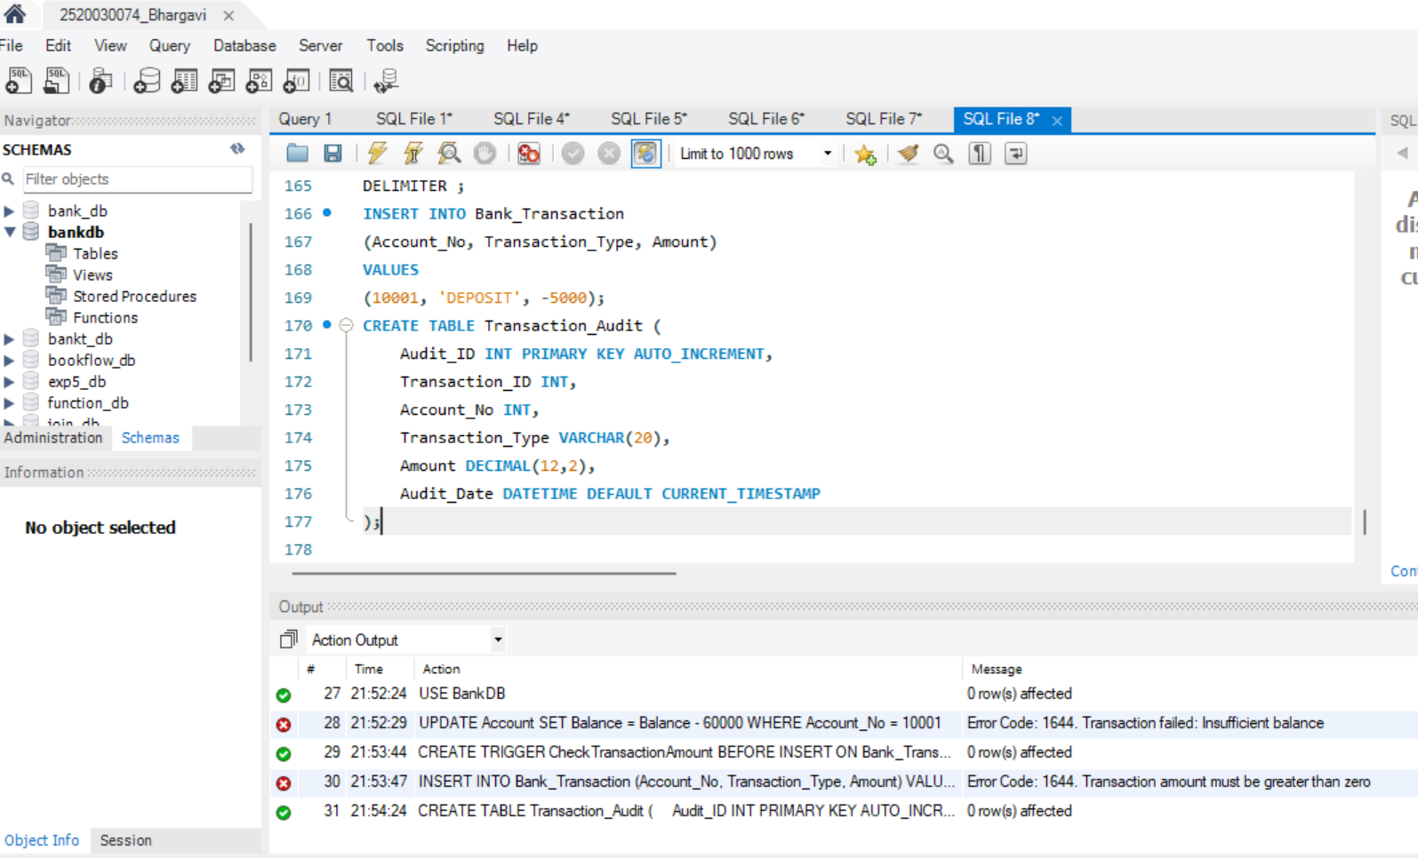
STEP-13: TRIGGER – TRANSACTION AUDIT
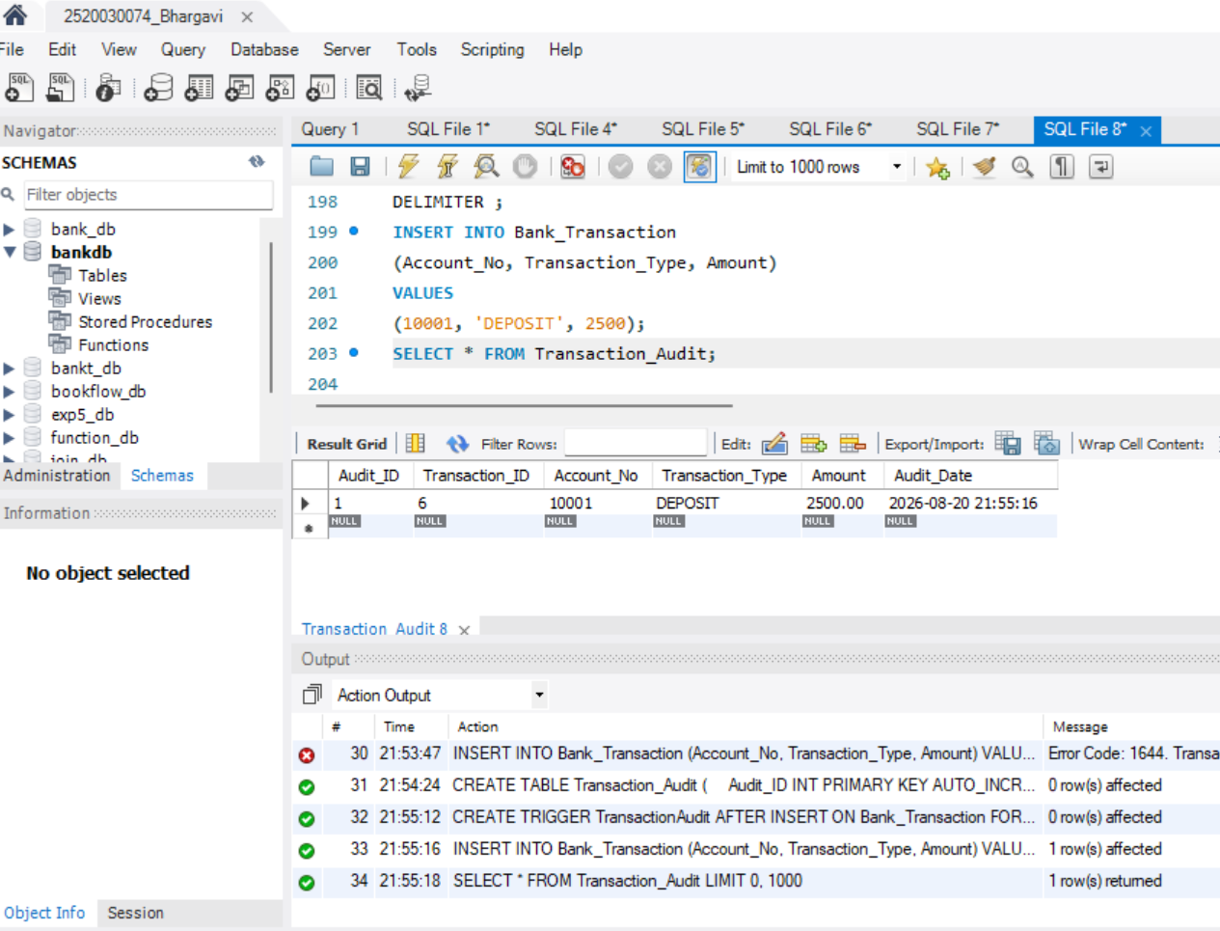
STEP-14: TRIGGER – AUTOMATICALLY UPDATE ACCOUNT BALANCE
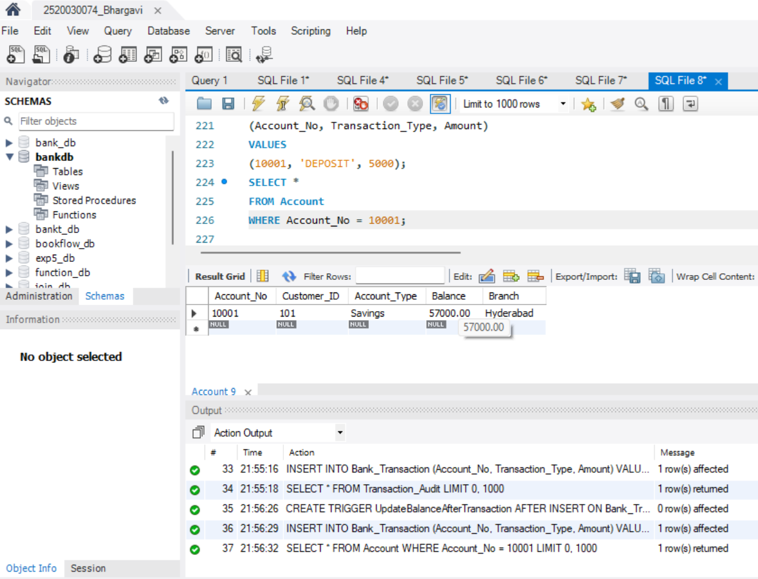
STEP-15: TRIGGER – PREVENT WITHDRAWAL ABOVE BALANCE
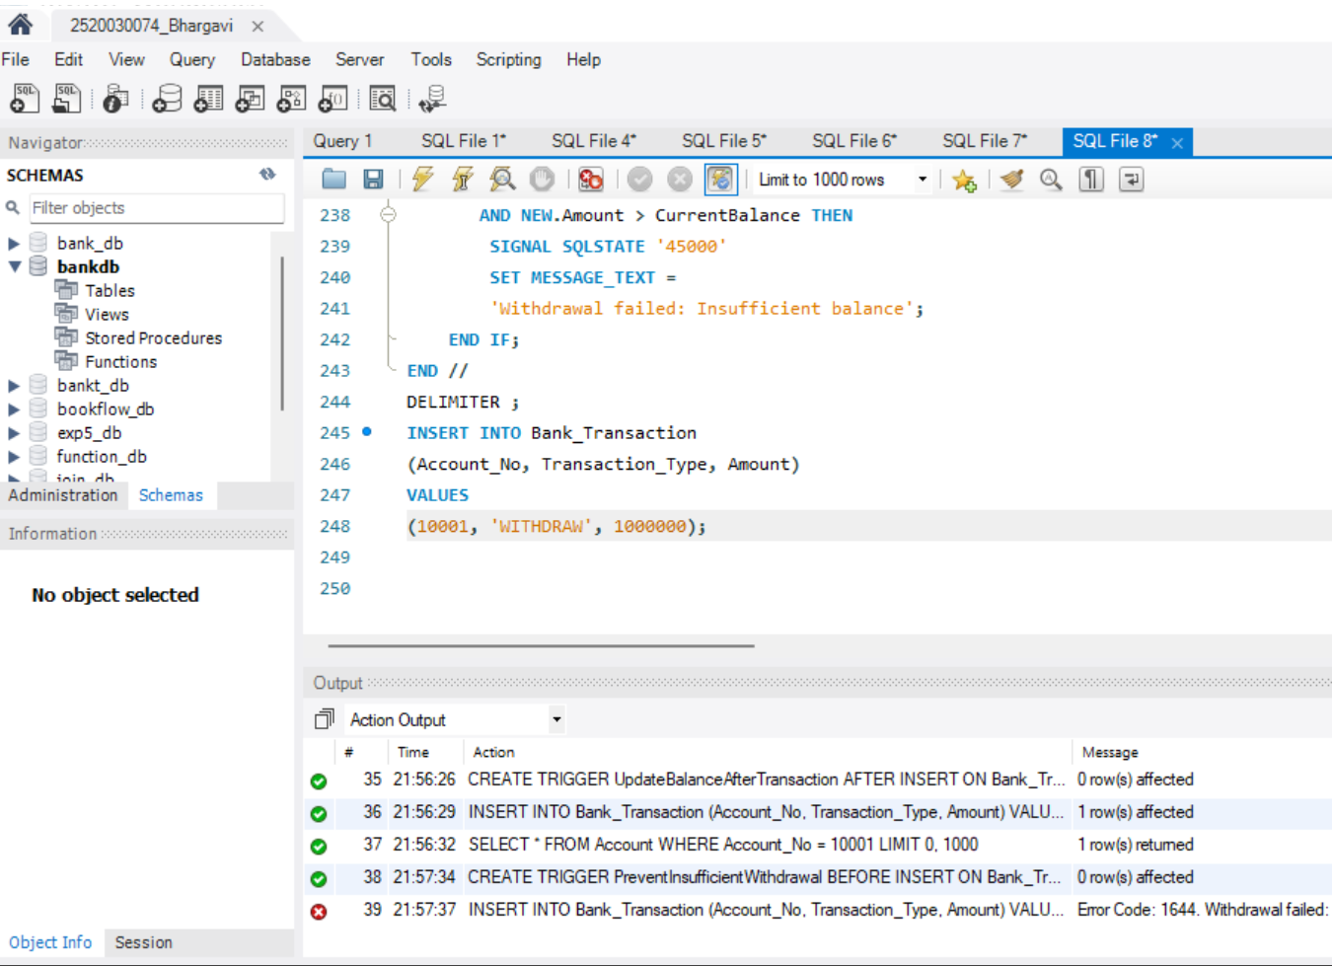
STEP-16: PROCEDURE – ACCOUNT TRANSFER
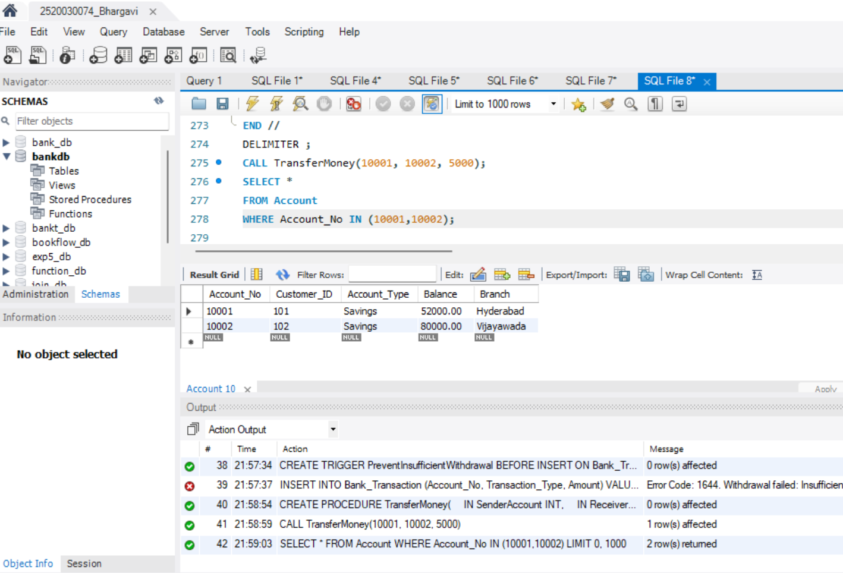
STEP-17: PROCEDURE – CUSTOMER LOAN DETAILS
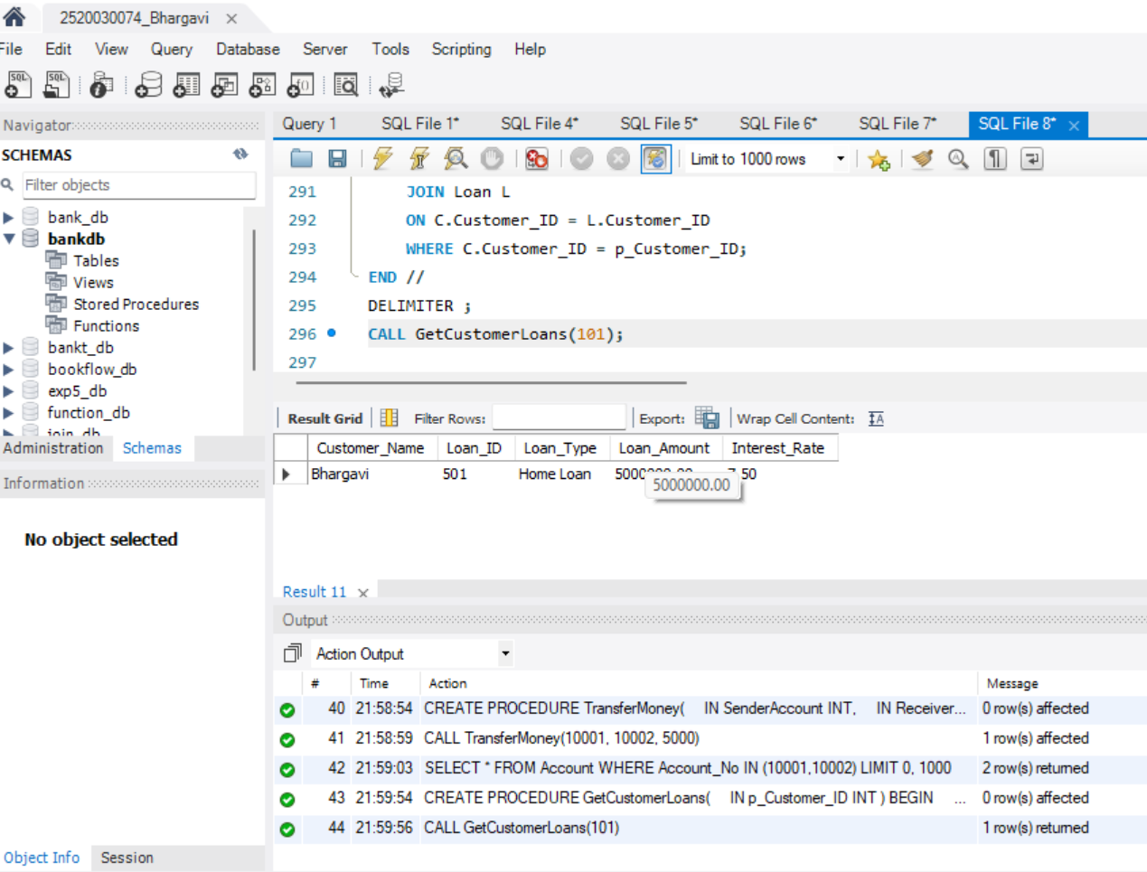
STEP-18: PROCEDURE – HIGH BALANCE ACCOUNTS
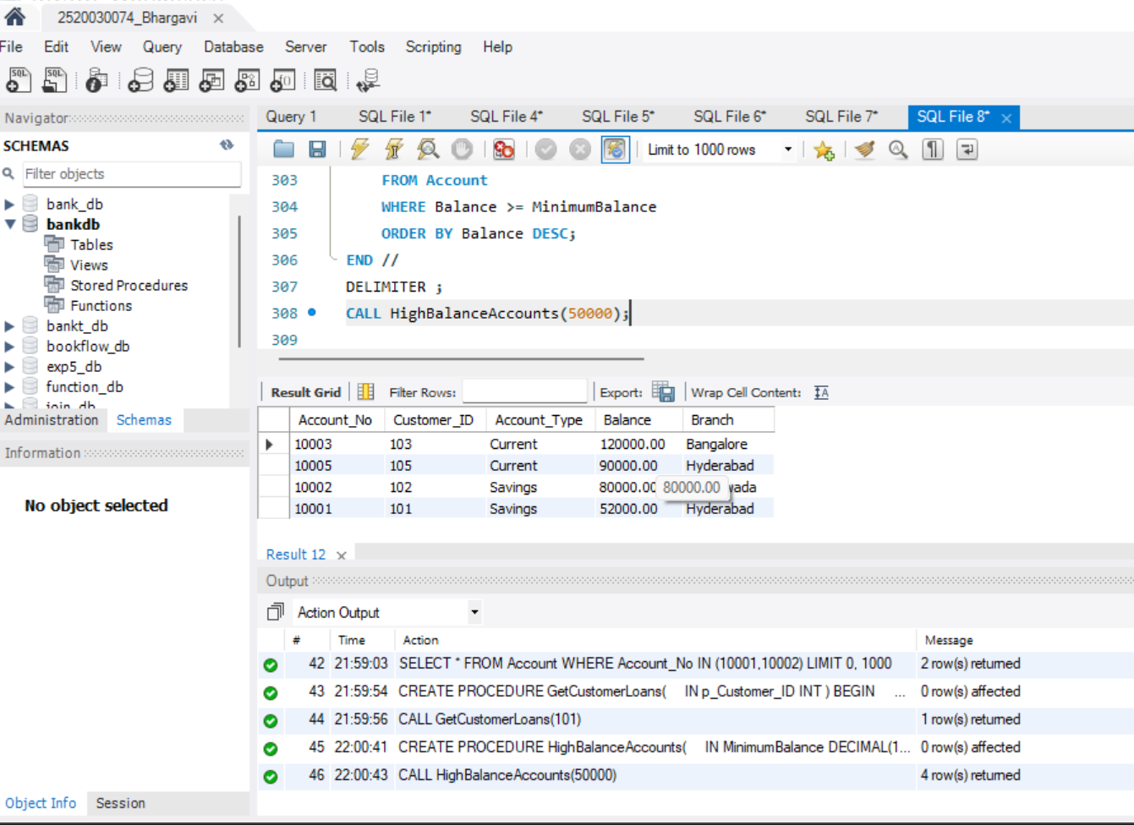
STEP-19: PROCEDURE WITH IN AND OUT PARAMETERS
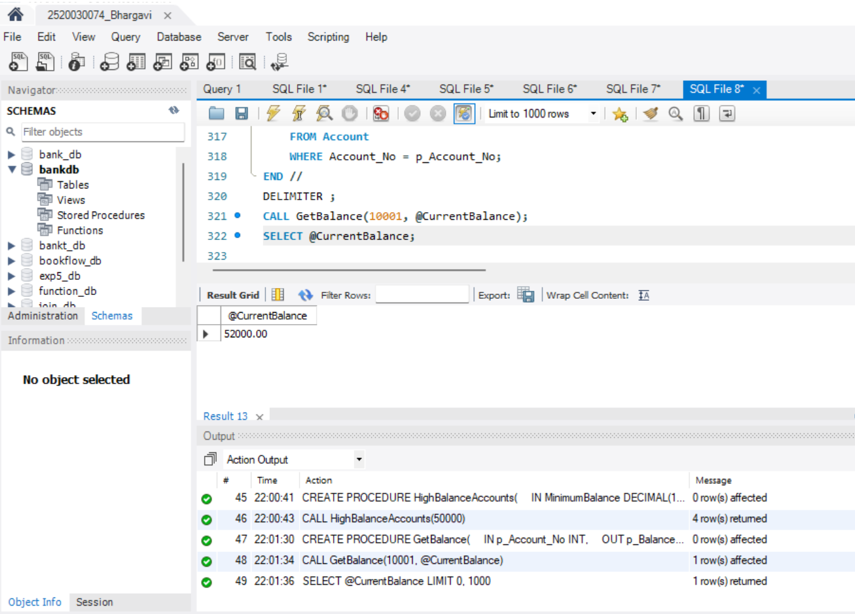

Question 1:
Create a procedure to display all accounts belonging to a
particular branch.
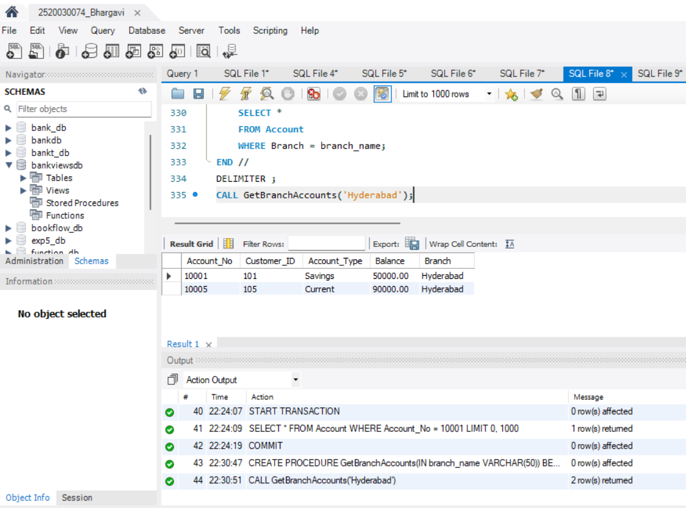
Question 2:
Create a procedure that accepts Customer_ID and displays:

Customer Name
Phone
Email
Account Number
Account Type
Balance
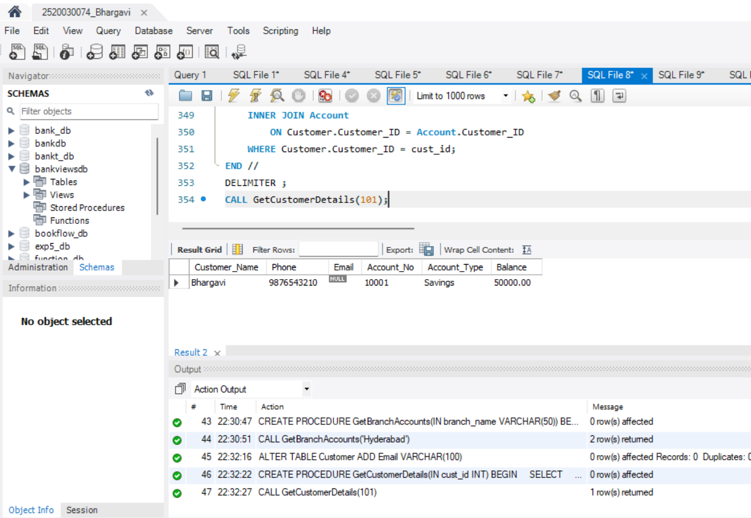
Question 3:
Create a procedure to calculate the total balance of all
accounts belonging to a particular customer.
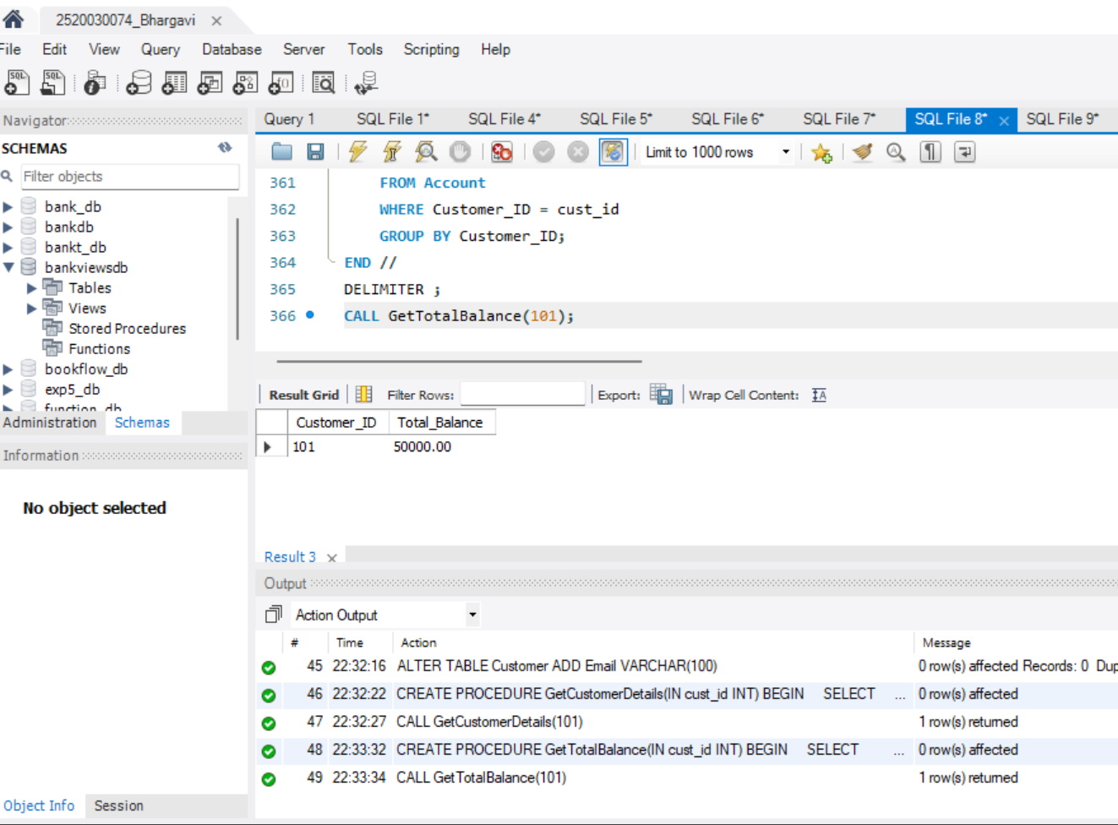
Question 4:
Create a procedure to display accounts whose balance is
greater than a given amount.
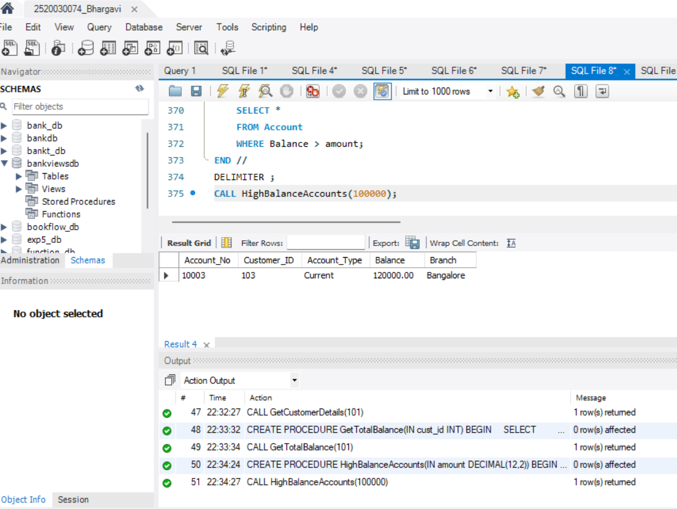
Question 5:
Create a trigger that prevents an account balance from
becoming negative.
